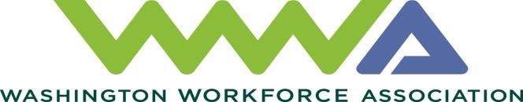
2021 Board of Directors

Tiffany Scott, Chief Executive Officer
WWA Chair
Benton-Franklin Workforce Development Council Serving Benton and Franklin Counties
tscott@bf-wdc.org
(509) 734-5993

Joy Emory, Chief Executive Officer
WWA Vice Chair
Workforce Snohomish on behalf of Future Workforce Alliance
Serving Snohomish County
Joy.emory@workforcesnohomish.org
(425) 921-3482

Marie Kurose, Chief Executive Officer

WWA Treasurer
Seattle-King County Workforce
Development Council
Serving King County
mkurose@seakingwdc.org
(206) 448-0474

Kevin Perkey, Chief Executive Officer
Workforce Southwest Washington Serving Wahkiakum, Cowlitz and Clark Counties kperkey@workforcesw.org
(360) 567-1070

Amy Martinez, Chief Executive Officer
South Central Workforce Development Council
Serving Yakima, Kittitas, Klickitat and Skamania Counties
Amy.Martinez@co.yakima.wa.us
(509) 574-1950

Cheryl Fambles, Chief Executive Officer
Pacific Mountain Workforce Development Council
Serving Grays Harbor, Mason, Thurston, Pacific and Lewis
Counties
Cheryl@pacmtn.org
360-570-4240

Katie Condit, Chief Executive Officer
WorkForce Central
Serving Pierce County kcondit@workforce-central.org
(253) 495-8515

Rod Van Alyne, Director
Eastern Washington Partnership Workforce Dev. Council
Serving Ferry, Pend Oreille, Garfield, Stevens, Lincoln Whitman, Columbia, Walla Walla and Asotin Counties rvanalyne@ruralresources.org
(509) 684-8421

Mark Mattke, Chief Executive Officer
WWA Workforce Board Representative
Spokane Workforce Council
Serving Spokane County mmattke@spokaneworkforce.org
(509) 960-6263

info@washingtonworkforce.org

